AM000-Asia-China-Tang-Animals and Grapes-618-907 CE

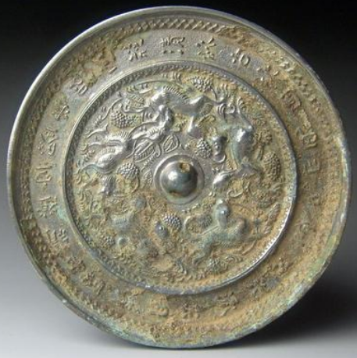

Five running animals and grapes mirror, 5.l in., 398 gm.

The flowing motion of the five animals running counter-clockwise around a central boss provides a sense of continuous motion. The nature of these animals may be partly mythological and partly real. The out band contains a poem in quatrain. Another mirror of this design has the a poem that reads: I received a gift: the mirror of the King of Qin. For this, I would have paid willingly a thousand teels of silver. In no way would I use it to unveil your hidden desires. Verily, I wish to lay bare my own heart (Chou 2000:62-63)." This mirror may have a similar poem on its outer band. The legend of the King of Qin's mirror was that it operated like an X-ray machine, revealing the bodies who stood before it. The poet in the case of this mirror wishes only to reveal the innermost thoughts of his own soul.

Iconographically, one might associate the structure and imagery of this mirror with those of the lion and grapes design. If so, then this mirror would be placed in the early Tang period. It would also argue for the fact that grapes were newly introduced from Xinjiang in western China so that the grape imagery was dependent on this cross-cultural connection in the later Sui Dynasty (589-618 CE).

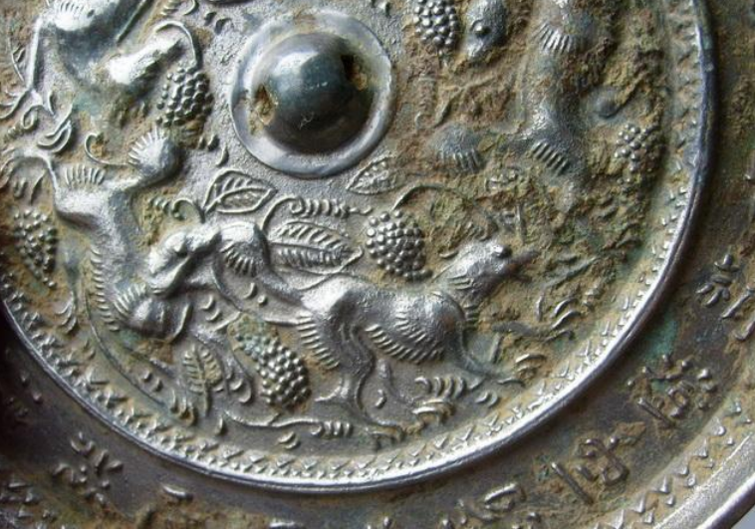

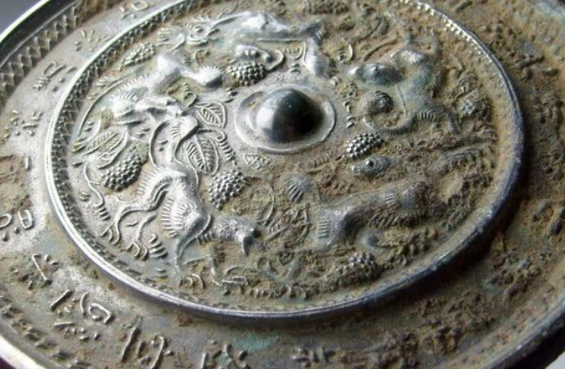

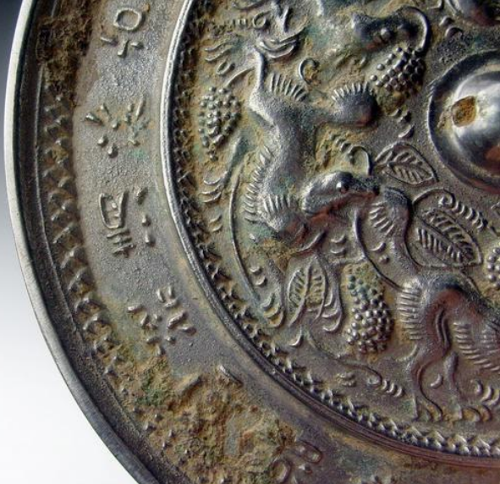

# Tang Dygrapes inscriptions(Liu Guang Shu Yue)bronze mirror 5.1in*398g